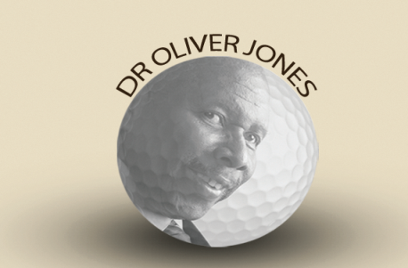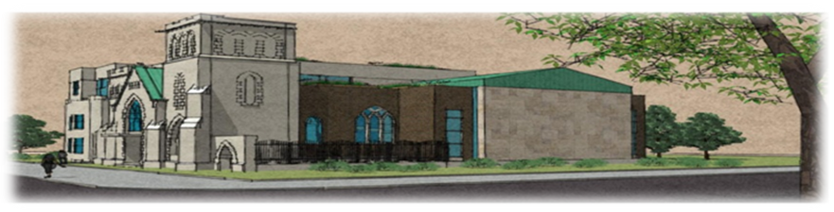

Dr. Oliver Jones Golf Tournament
Club de Golf Atlantide Golf Course,
2201 Boulevard Don Quichotte, Notre-Dame-de-l'Île-Perrot, QC J7V 7P2
Friday, August 19, 2016

SPONSORSHIP FORM

Platinum Sponsors $1,800  - Team photos with Dr. Oliver Jones  - Hole Sponsorship  - Logo on sponsorship banner  - Recognition at registration table  - Recognition on Union website  - Golf and dinner for a 4 man team  - Tax receipt | Gold Sponsors $,1000  - Hole Sponsorship  - Logo on sponsorship banner  - Recognition at registration table  - Recognition on Union website  - Tax receipt
Silver Sponsors $300  - Hole sponsorship  - Recognition at registration table  - Recognition on Union website  - Tax receipt | Wine Sponsors $100  - Recognition on dinner signage  - Recognition on Union website  - Tax receipt

Name of Organization: _________________________________________________________________
Contact Name: ________________________________________________________________________
Address: ____________________________________________________________________________
Email: _______________________________________ Tel.: ___________________________________
Please select from the following sponsorship opportunities:
□ Platinum ......$1,800.00 □ Gold......$1,000.00 □ Silver......$300.00 □ Wine......$100.00

□ I have enclosed a cheque payable to the Union United Church. Please mail cheque to Union United Church 3007 Delisle, Montreal, Quebec, H4C 1M8
Tax receipts will be provided for the eligible portion of the fees.
For more information, please contact June Keene Tel.: (514) 743-1397; Email: j_keene@hotmail.com or Athenia Charles Tel.: (514) 220-0538; Email: atheniacharles943@gmail.com

